Frequently Asked Questions about the Integral Ministry Program

Special thanks to Cynthia Heyn and Lynne Patterson for posing these questions and to Unity of Dallas’ Leadership & Board for contributing to the growing body of resourses that support all who are on the journey to Integral Ministry.

1. **What is the Integral Ministry Program?**

The Integral Ministry Program (IMP) as formulated by Dr. Gary Simmons, approaches ministry as a living system and emphasizes the importance of aligning ministry practices with the fulfillment of the evolutionary purpose[1] in peoples’ lives and beyond. It also involves fostering inclusive, collaborative, and consciousness-raising practices. The integral approach considers multiple perspectives and stages of development—addressing both inner and outer aspects of individuals and communities.

Integral Ministry is an approach to church leadership and community building that focuses on personal and collective transformation. It is based on the idea of "integral" thinking, which means seeing things in a holistic, interconnected way. The core principle is to integrate both the inner personal growth of individuals and the outer functioning of the church as a whole.

Dr. Simmons' model combines spiritual development with practical strategies to help church communities thrive. He encourages leaders to shift from a "minister-centered" model, where the focus is on the pastor, to a "mission-centered" model, where the entire congregation takes part in fulfilling the church’s purpose. This creates a more inclusive and empowered community.

In short, Integral Ministry is about building a spiritually thriving, inclusive, and mission-driven community where every individual feels empowered and responsible for the collective mission of the church.

1. **What are the key components of the Integral Ministry Program?**

Key components of Integral Ministry include:

1. **Personal Transformation**: Encouraging everyone in the church community to focus on their own spiritual growth, healing, and development.
2. **Shared Leadership**: Moving away from the traditional top-down leadership style to one that values collaboration and shared responsibility among all members.
3. **Wholeness**: Addressing not just the spiritual needs but also the emotional, relational, and practical aspects of the church community, ensuring that the ministry supports all dimensions of life.
4. **Sustainability**: Creating a church structure that can grow and evolve over time without burning out the leaders or becoming stagnant.

The various innovative elements of the Integral Ministry Program are informed by research on organizational development and paradigmatic growth. It includes such dynamics as:

* Quantum Living Process
* SpiritGroups
* Integral Membership
* Integral Welcoming System
* Evolutionary Purpose
* Spiritual Cooperative
* Genogram Activity
* Conscious Conversations
* Mapping What Is
* Quantum Living Process for Teams
* Weekly Updates
* Integral Job Descriptions
* Integral Employee Review Process
* Board and Leadership Development

1. **Why should our church adopt the Integral Ministry Program?**

The current 400-year-old minister-centric model is wrought with unintended consequences such as decline in several areas: membership, leadership, volunteer engagement and financial support. In addition, the present model can devolve into dysfunctional and unnecessary drama.

Research has shown that the aging out of the Baby Boomer generation will render most established ministries unsustainable within two decades.

The Integral Ministry Program and its shared leadership approach, new funding model, membership system and Quantum Living Practice, is designed to address these and other issues in promoting a more empowered and engaged congregation.

1. **How can we assess if our church is ready for this practice?**

By answering these questions:

* Is your ministry facing the kinds of issues and unintended consequences listed above?
* Is there an overwhelming sense that things need to change, and that the ministry can no longer continue doing things the way they have been done in the past?
* Is there a desire and willingness to change and evolve?

1. **How does the Integral Ministry Program differ from traditional church models?**

The “plop, pray and pay” model of traditional ministry has unintended consequences listed above in Question #3. The Integral Program is designed to transcend these issues but include what works well for the ministry.

The well-being of the ministry no longer rises and falls only on the capability of the spiritual leader, but on the fulfillment of the evolutionary purpose. The Integral approach’s intent is to cultivate ownership, engagement and involvement rather than merely passive participation, and strives to 100% underwrite the operational expenses through automatic giving. In addition, the IMP helps to heal patterns of the past by identifying and addressing the ministry’s shadow qualities (limiting beliefs) as well as who and what the ministry has come here to be (core values).

Another difference is the use of the Evolutionary Council – through two activities, Conscious Conversations and Mapping What Is. Both undertakings help to reveal and identify processes and systems not aligned with the fulfillment of the evolutionary purpose, or unconscious activities rooted in past imperatives that are no longer supported by the members of the ministry.

The goal is to develop the values of ownership, partnership, self-responsibility and personal integrity.

1. **How does the Integral approach align with Unity’s core principles and teachings?**

The Integral approach aligns with Unity principles by exploring ways to:

* Live our lives with nothing and no one against us (Principle #1)
* By embodying our Divine Nature (Principle #2)
* Change our thinking and transform our lives (Principle #3)
* Practice body-based meditations (Principle #4)
* Be the change, put principle into practice (Principle #5)

1. **What changes will we see in our services and teachings with the Integral Program?**

The things that *don’t* change are whatever the community values, appreciates and loves about your Sunday service, your Programs, and/or Community events and gatherings. The IMP will introduce and enhance programs such as Integral membership, Quantum Living Process, Spiritual Cooperative Funding Model, SpiritGroups small group ministry, board and leadership development, and the fulfillment of evolutionary purpose in one’s life.

1. **How does the Integral approach promote personal spiritual growth in alignment with Unity’s teachings?**

Personal spiritual growth is promoted through all the various programs and begins with the practice of the three essential elements of the Integral Program: fulfillment of the evolutionary purpose, participation in SpiritGroups, practice of The Art of Quantum Living, as well as body-based meditative practices. See question 6 for how the program is aligned with Unity Teachings.

1. **Will the role of the minister change, and how will this affect our spiritual guidance?**

In Integral Ministry, the role of the minister shifts from surrogate parent in the family system with sole responsibility for the well-being of the ministry, to partnering with ministry leaders as Coach and Facilitator of the evolutionary process. The minister continues in the ongoing spiritual care of the community, retaining spiritual guidance practices, spiritual counseling, pastoral care, prayer support, as well as sharing transformational Sunday talks and educational teachings.

1. **How will Integral Ministry impact the community aspect of our church?**

The congregation shifts from being a collection of individuals to embodying the principles of The Beloved Community. Although congregants will still find community in similar ways as they currently do, Spirit Groups will enhance community as people find their need for connection met through small group gatherings.

1. **How does Integral Ministry support Unity’s principles of inclusivity and oneness?**

Learning about and practicing communication with the various cultural worldviews typically found within ministries (traditional, modern and postmodern) honors diversity. In addition, participation in Spirit Groups can greatly enhance inclusivity,

1. **How will decisions be made in the Integral Program, and what role will congregants play?**

In essence, the IMP seeks to create a culture where decisions are co-created through a process that honors the spiritual, emotional, and operational dimensions of the community. This requires a high degree of transparency, empathy, and commitment to shared values, ultimately fostering a spiritually aligned and participatory approach to ministry leadership.

Board members will continue to make decisions around fiscal governance. The minister is still in charge of the staff and the day-to-day operations of the ministry. Congregants are given regular updates on the Integral Program through Center Updates, and can weigh in on decisions through Town Hall meetings, Conscious Conversations, Mapping What Is, and consulting with the Evolutionary Advisor.

In some system-wide matters, such as choice of new spiritual leader, congregants are invited to give feedback and input. In other situations, such as approval of by-laws, the congregation will vote on their adoption.

1. **How will this shift impact our existing programs and activities that are based on Unity teachings?**

There will be no change to those programs and activities. Unity classes will still be offered as they have been in the past. Spirit Groups can also become an avenue for greater learning and practicing of Unity teachings.

1. **What are the first steps to implementing the Integral Ministry Program?**

The first steps of IMP include the adoption of three essential components of Integral Ministry: The Evolutionary Purpose Statement, Spirit Groups, and the Quantum Living Process.

1. **How do we align our current ministries with the Integral Ministry Program?**

Begin by seeing how each ministry aligns (or doesn't) with the evolutionary purpose of *transforming lives and inspiring people to make a positive difference in our world*. If it does not align with it, look for ways that it could be aligned.

1. **What are some common challenges in implementing the model?**

Common challenges are resistance to change, fear of trying something new, lack of understanding around how church culture evolves, desire to “do one’s own thing”, (i.e. the ‘herding cats’ syndrome) aversion to shadow work, sense of not enough, dysfunctional relationships, predict and control leadership imperatives,

1. **How can we overcome resistance to change?**

By including all stakeholders in the conversation wherever they find themselves on the Bell Curve when it comes to Innovation. Some are identified as Early Adopters, other Pragmatists, Skeptics, and those who are happy with the Status Quo – all have a voice and a valuable perspective to contribute. Education about the program is imperative and any concerns raised need to be acknowledged and addressed.

1. **How does the program handle feedback and adaptation?**

Through communication with the Evolutionary Advisor, Town Hall meetings, and through the coaching practice if chosen.

1. **Can the model be customized to fit our specific needs?**

It depends! Requests for modifications are considered on a case-by-case basis. However, until the program has a chance to take root, no modifications are encouraged until there has been sufficient time for it to be fully established. It has been noted that clients who have made significant changes to the program have later regretted doing so.

1. **What long-term outcomes can we expect from fully implementing the program?**

The IMP aims to increase board and leadership development, improve communications within the community, reduce drama and triangulation, increase engagement in sacred service and participation in small groups, and create greater capacity to embody positive change. The program is ultimately designed to assist in generating 100% underwriting of operating expenses through automatic giving.

1. **What is the implementation process?**

See implementation arenas map below:

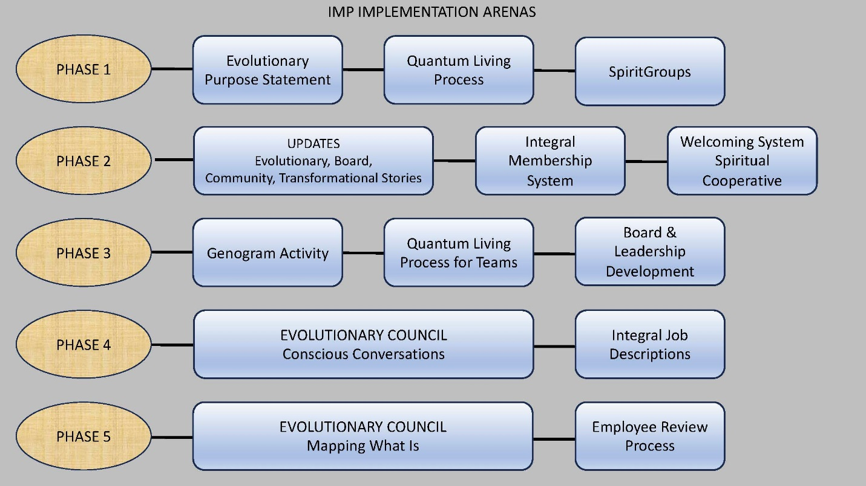

1. Transforming lives and inspiring people to make a positive difference in our world.